Submitted on time? (YES/ NO): Yes

**Task 01**: Complete the Table 01. **50 points**

**Task 02:** Attach screenshots of the simulated circuit of the experiment showing all Multimeter/ simulation readings as mentioned in the class. **30 points**

**Task -03:** Answer to the given question. **20 points**

**Name & ID:** Md. Rifat Ahmed ~ 1931725042

**Task: 01**

## Table 4.1: Data for I - V characteristics

|  |  |  |  |
| --- | --- | --- | --- |
| V  (volts) | VR  (volts) | Vz  (volts) | Iz = VR / R  (mA) |
| 0.1 | 9.448 µV | 99.991 mV | 19.999 nA |
| 0.7 | 66.13 µV | 699.934 mV | 139.988 nA |
| 1.0 | 94.472 µV | 999.906 mV | 199.984 nA |
| 3.0 | 283.414 µV | 3 V | 599.965 nA |
| 5.0 | 92.521 mV | 4.907 V | 196.848 µA |
| 6.0 | 1.044 V | 4.956 V | 2.221 mA |
| 10.0 | 5.013 V | 4.987 V | 10.665 mA |

Table 4.2: Data for Load Regulation

|  |  |  |  |
| --- | --- | --- | --- |
| POT_R (k ohm) | V220 (mV) | VL (volts) | IL (Amp)= V220/220 |
| 1 k | 897.643 mV | 4.978 V | 4.08 mA |
| 3 k | 340.542 mV | 4.984 V | 1.548 mA |
| 5k | 210.119 mV | 4.986 V | 955.092 µA |
| 9k | 118.981 mV | 4.986 V | 540.828 µA |
| 10k | 107.341 mV | 4.986 V | 487.92 µA |

Table 4.3: Data for Line Regulation.

|  |  |
| --- | --- |
| V (volts) | VL (volts) |
| 1.0 | 721.844 mV |
| 3.0 | 2.166 V |
| 6.0 | 4.331 V |
| 9.0 | 4.97 V |
| 10.0 | 4.978 V |
| 11.0 | 4.983 V |
| 12.0 | 4.988 V |

**Task: 02**

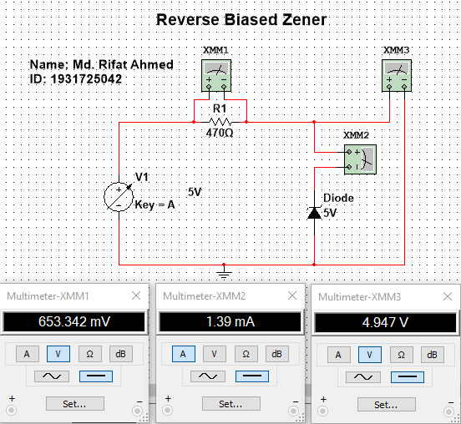

Figure 1: Reverse Biased Zener Circuit

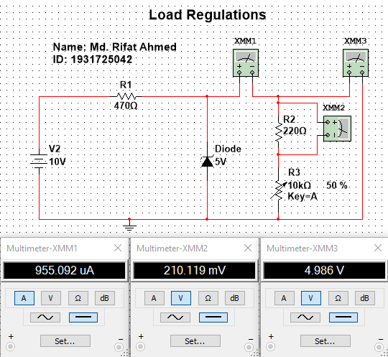

Figure 2: Load Regulations Circuit

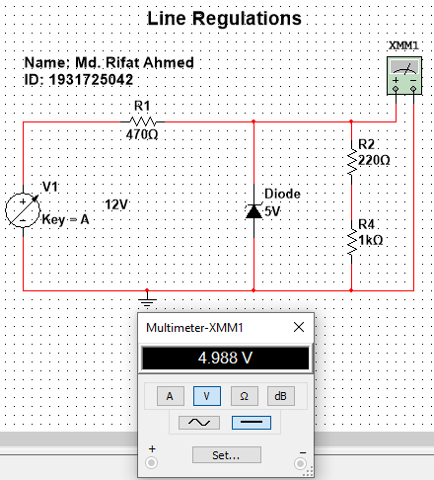

Figure 3: Line Regulations Circuit

**Task: 03**

1. What is the difference between a Zener Diode and a diode?

**Ans:** A normal diode only conducts in the forward bias region and does not conduct when reverse biased because they might be damaged if they’re reverse biased. But on the other hand, a Zener diode can conduct in three regions: forward, leakage and breakdown. In forward bias region it acts like a normal silicon diode, in the leakage region it can conduct a small amount of reverse saturation current and in the breakdown region it works for a fixed amount of voltage.

1. What is called a Zener Voltage?

**Ans:** The voltage that causes a diode to enter the Zener region in the negative bias region is called Zener voltage (VZ).